Report to Department for Supervision on Animal and Plant
Quarantine General Administration of Quality, Supervision
Inspection and Quarantine of the People’s Republic of China
Regarding Changes Made at Ocean Star International, Inc.,
Snowville Utah, USA for Production of Brine Shrimp Flakes

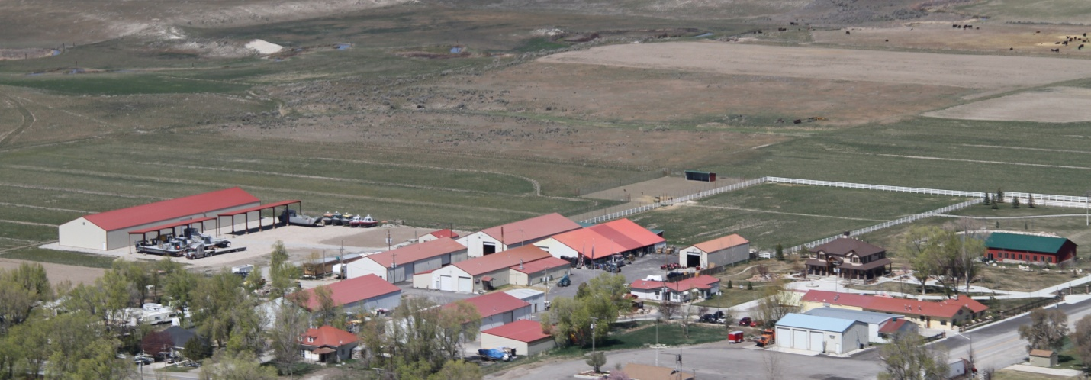
OSI Plant Areal view

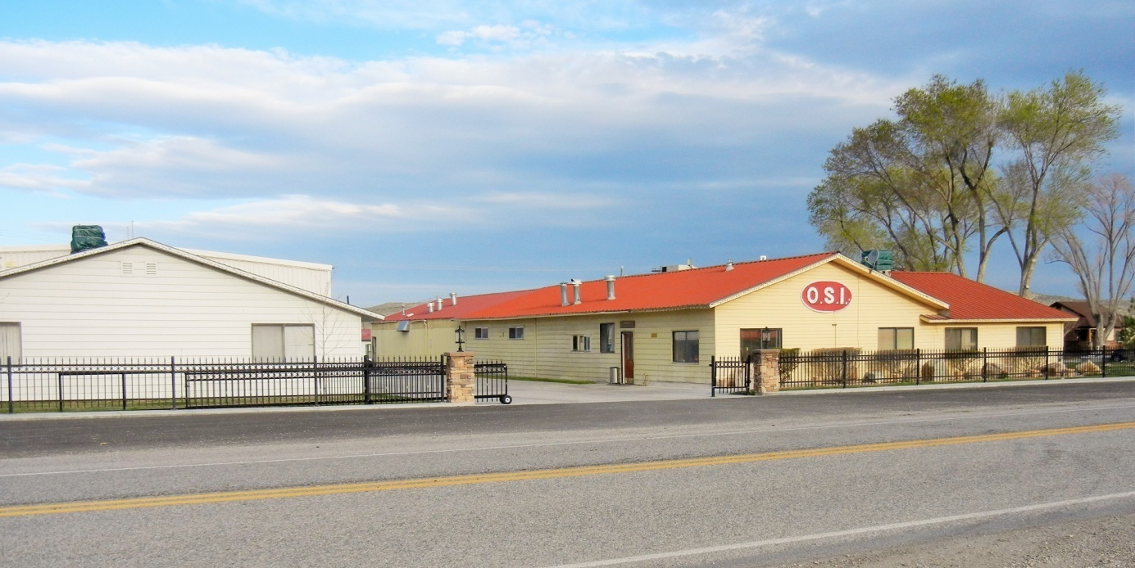
OSI Plant Entrance

OVERVIEW AND RATIONAL

In September 2013 Ocean Star International, Inc. (OSI) was notified that its Brine Shrimp Flakes (BSF)were no longer being accepted for import into the People’s Republic of China. The reason for this rejection was due to the flakes being found to be out of specification for Chromium, Acid Value, and Polychlorobiphenyls. In a report to ZHAO Zenglian, Deputy Director General, Department for Supervision of Animal and Plant Inspection and Quarantine AQSIQ, Dr. Cynthia Duerr of the United States Department of Agriculture, Animal and Plant Inspection Service (USDA, APHIS) Beijing Office,
wrote a letter on November 3, 2014 indicating that OSI has resolved these problems and this has been confirmed by the local USDA, APHIS personnel. A copy of this letter is included (Addendum 1).

PRIMARY PROBLEM AND SOLUTION – Fish Meal

The primary reason for the out-of-specification problems was that OSI bought menhaden fish meal from a company called Omega Protein, Inc., Moss Point, Mississippi, USA. Menhaden are small coastal fish found in the Gulf of Mexico. These fish have higher levels of contaminants due to living in the area where the Mississippi River empties into the Gulf of Mexico. The menhaden picked up the contaminants from the river and that was expressed in the fish meal. At the same time our products were restricted for import to China, the fish meal from Omega Protein, Inc. was also restricted. OSI sent our stock of this fish meal to the garbage.

OSI started to look for a new fish meal source. We now purchase Pacific Hake fish meal from American Seafoods Company, LLC, Seattle, Washington USA. Pacific hake are mid-ocean fish captured in the Pacific Ocean in the area between the States of Washington and Alaska USA. This fish meal is manufactured on large factory ships at sea. So, the fish meal is very fresh and free of contaminants associate with coastal fishes. According to American Seafoods Company, 95% of the fish meal they process goes to China, Japan and South Korea. This substitution has been the main change to OSI’s Brine Shrimp Flake ingredients to solve the contamination problems and improve our product.

American Seafoods Company is qualified by supplying OSI with a Certificate of Thermal Treatment for the fish meal, Certificate of Conformity, to SAI Global Assurance, ASI Accreditation Code AA-MSC-019 meeting Marine Stewardship Council requirements, HACCP Plan, and general analyses, including ethoxyquin (US Food and Drug Administration requirement for transport of fishmeal on US vessels and trucks), and total volatile nitrogen and histamine. Representative samples are included in Addendum 2.

ADDITIONAL CHANGES TO IMPROVE QUALITY

To further improve the brine shrimp flakes, changes in buildings, equipment, and other cGMP procedures were instituted. This report gives further details about what has been changed and implemented at OSI’s BSF Production since September 2013.

GRINDING FISH MEAL

Fish meal is one of the major ingredients in the manufacturing of Brine Shrimp Flakes. Typically its particle size is too large for baby shrimp and fish to eat. In high-quality flakes all particles must be as small as possible. OSI grinds the fish meal we get from American Seafoods Company to where at least 80% of the particles are smaller than 0.05 mm. When the flakes are then manufactured and later processed for feeding to animals, they will be sufficiently small to include multiple ingredients in each particles. This is essentially a form of microencapsulation where each food particle contains multiple ingredients. It is vast improvement over other types of feeds where a single food particle may only contain one ingredient.

BUILDINGS - GENERAL

The flake production system at OSI includes the following areas:

Ingredient Storage Area for Fish Meal
Grinding Room for Fish Meal
Ingredient Storage Area for Other Ingredients
Flake Production Buffer Room (Sally Port) / Clothes Changing Area

Flake Production Plant, Including:

Ingredient Measuring Area
Mixing Area
Double Drum Flaking
Drying Area
Equipment Washing and Drying
Flake Cooling Area
Generator, Air Compressor and Boiler Area

Finished Flake Storage Warehouse
Flake Packing Materials Storage Area
Flake Packaging/Storage Area
Laboratory

Ingredient Storage Area for Fish Meal

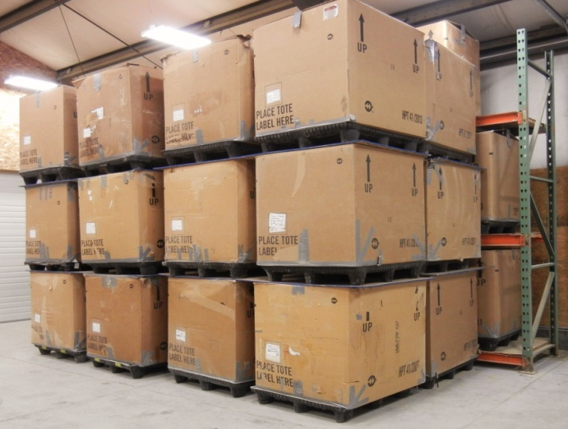

Remodeled in late 2014, this area includes approximately 200 m² for the storage of fish meal only. This area is cooled to approximately 10° C. The room is sealed and a pest control system, consisting of a variety of traps, is used to control both rodents and insects. Access is limited for ingredient ingress and egress for flake production through one rollup door.

Grinding Room for Fish Meal

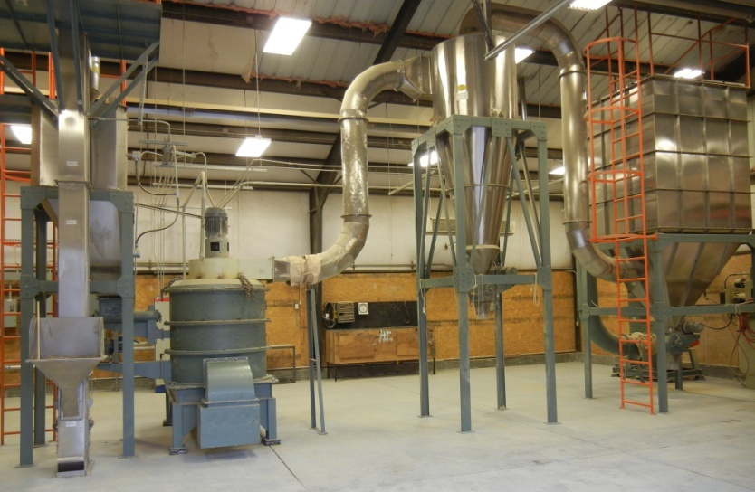

This area is approximately 220 m². It is located next to the Fish Meal Ingredient Storage Area and accessed through two rollup doors. Dust from the grinding operation is controlled through cyclones and ventilation fans. Pest control is also in place. This area operates at ambient room temperature.

Ingredient Storage Area for Other Ingredients

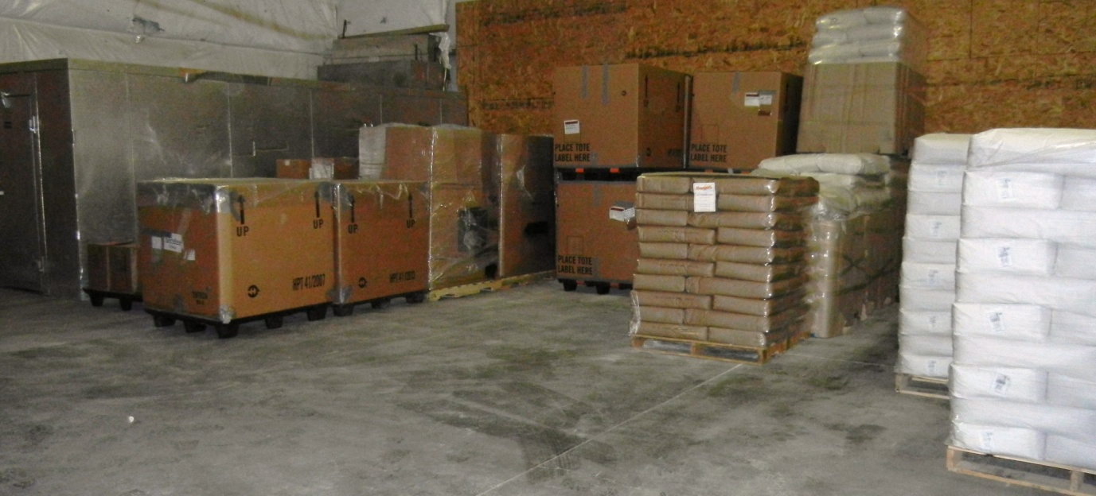

This area includes approximately 170 m². All ingredients except for fish meal for the production of BSF are stored in this area. This area is cooled to approximately 10° C. The room is sealed and a pest control system, consisting of a variety of traps, is used to control both rodents and insects. Access is limited into this area via 2 rollup doors in a sally port configuration. The sally port limits access to the area and keeps the area cleaner. The ingredients are moved only through this port.

Flake Production Buffer Room (Sally Port) / Clothes Changing Area

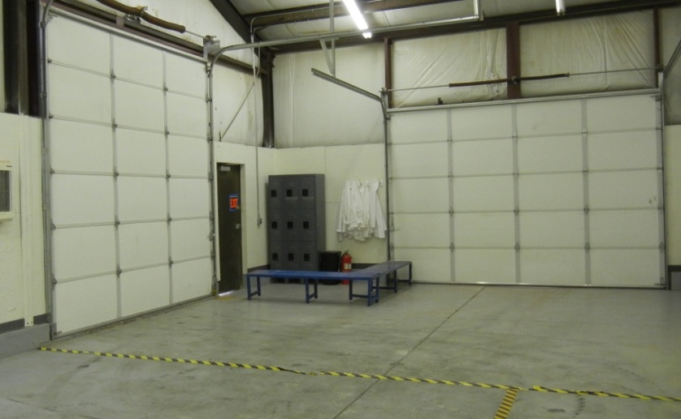

Remodeled in 2014, this area includes approximately 170 m². It has two main areas; one for ingress of ingredients and egress of finished products, and one for personnel to enter and exit the building. The room is in a sally port configuration. Incoming ingredients are moved into the sally port via a rollup overhead door on the east side. After ingredient drop off the fork lift exits. The outside door is closed and the ingredients are moved to the ingredient measuring area by pallet jack through a second (east side), inner rollup door.

Egressing finished flakes, packed and sealed in cardboard totes with plastic liners are deposited into the sally port from a west side rollup door servicing the Cooling Room. They are brought into the sally port

by pallet jack and the rollup door is closed. The outside west side rollup door is then opened and the finished totes are moved to cool storage. The incoming ingredients and the departing finished products’ paths do not cross. Nor are the operations of moving ingredients and finished totes done at the same time.

Also in this area is a Clothes Changing Area. A bench is provided to separate the outside from the current Good Manufacturing (cGMP) area. Employees enter via a man door to the south side of the change area. Uniforms and/or laboratory coats, hair nets and booties are donned before employees cross over the bench to the cGMP north side.

Flake Production Plant

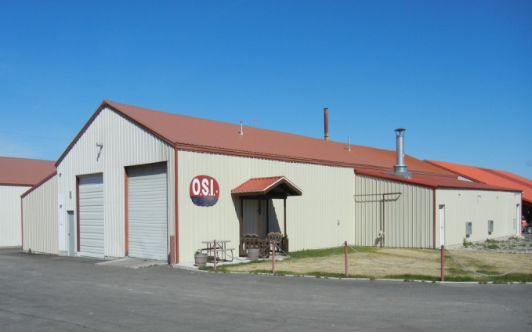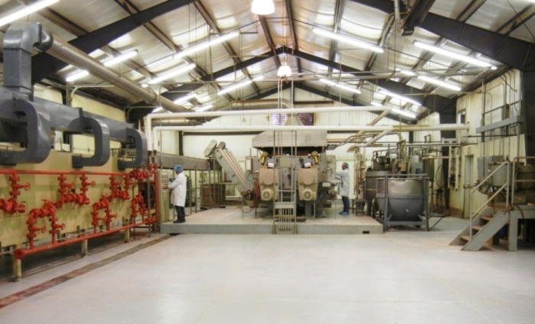

Flake production is done in one main plant. Approximately 560 m² is devoted to this area. This area is not air conditioned due to the high heat and steam generated in this area. However, it is heavily ventilated to ambient air. Screens are placed over fans to stop insects from entering. A UV light is used to also attract and control insects. Spring traps are used to control rodents. The floor is painted with a food-grade facility washable paint and walls are washable. Lighting is standardized to local work codes for State of tah, Box Elder County where the facility is located. Four main procedures are done in this area as follows:

Ingredient Measuring Area

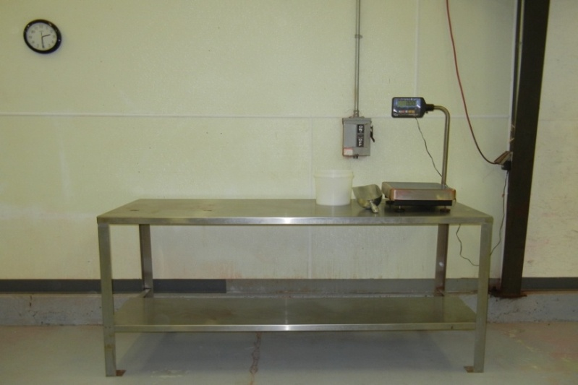

This area uses approximately 50 m². It has an area for the incoming ingredients to be stored and a stainless steel bench with various scales is used to measure ingredients.
Mixing Area
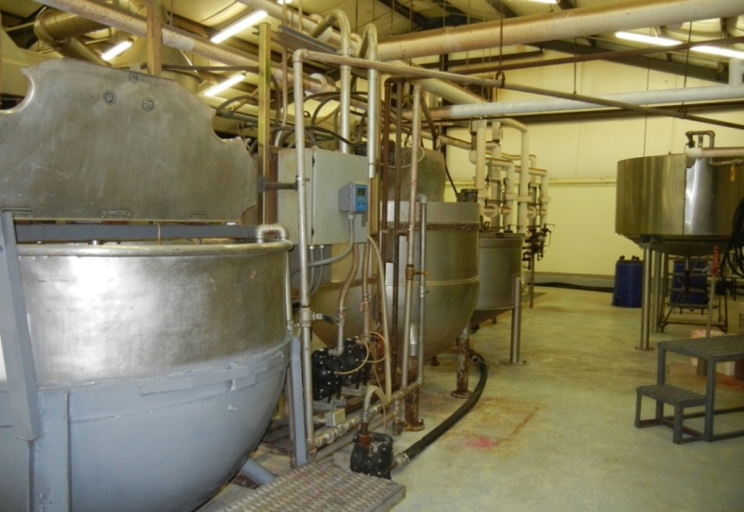

Approximately 70 m² is used for the mixing of ingredients. Hot water is generated in a steam-heated 1,100 L kettle. This water along with batch ingredients are mixed in two 1,500 L kettles. A variety of mixers are used to make a uniform batch mix.

Double Drum Flaking Area

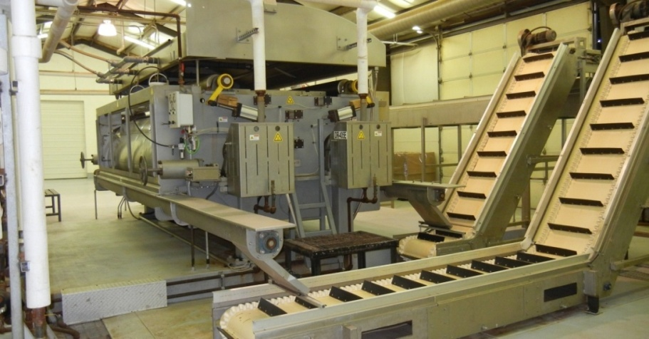

Approximately 90 m² is used for the actual flaking of the batch mixes. The mixes are pumped onto the rolls of a double drum dryer and flakes are created. Flakes are passed via a series of conveyors to a drying tunnel.

Drying Tunnel Area
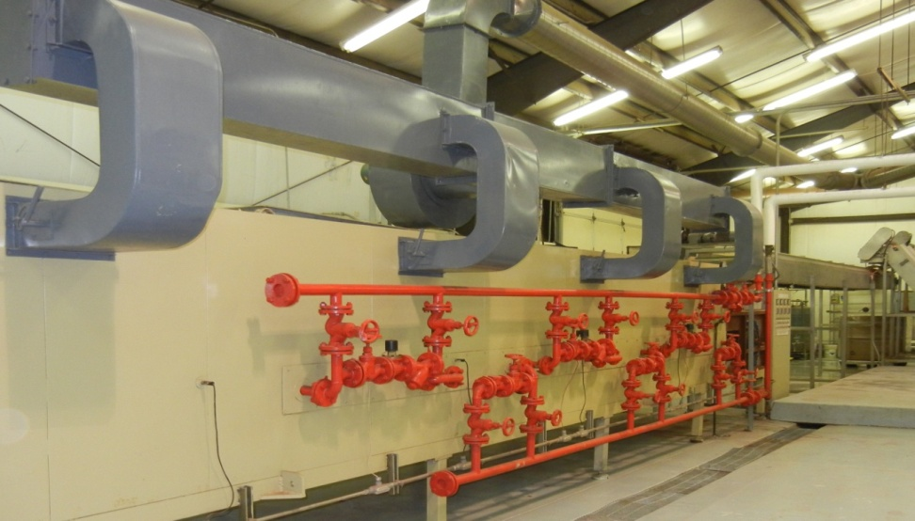

Approximately 80 m² is used for drying flakes. Flakes are transported through a drying tunnel and air cooled. Dried flakes are collected at the end of the drying tunnel in aluminum mesh totes.

Equipment Washing and Drying

Approximately 20 m² is used for washing measuring tools, and machine parts. A triple basin sink is located in this area along with drying racks.

Flake Cooling Area

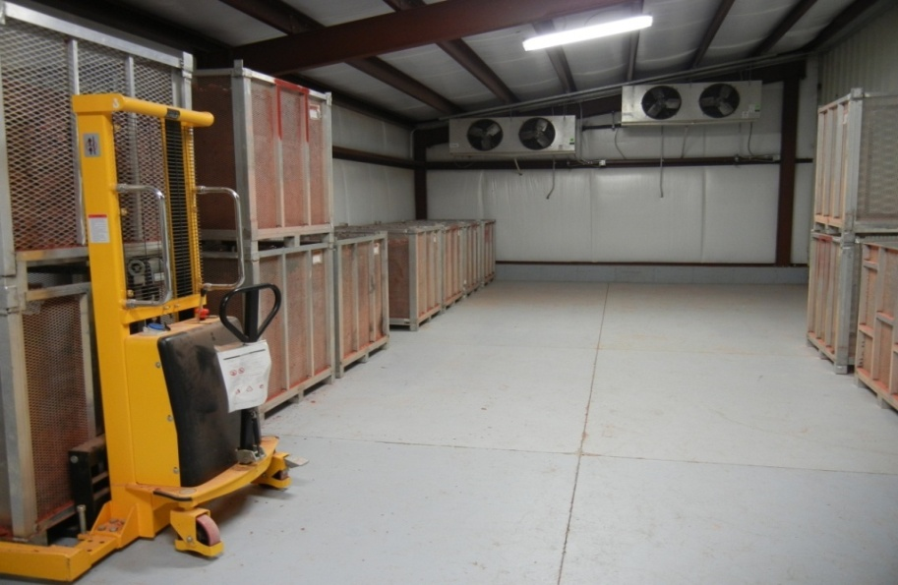

A room approximately 110 m² is used for additional drying of flakes. Flakes in aluminum mesh totes are moved into this area via a rollup door at the end where the flakes have been dried in the tunnel area. The temperature in this room is maintained at approximately 10° C. After additional drying the flakes are transferred into bulk storage cardboard totes with plastic liners. These totes are removed from this room to the sally part via a separate rollup door. The path of the incoming aluminum mesh totes does not cross the exiting cardboard totes. A UV insect control trap is used for capturing insects and rodent spring traps are used to capture and kill mice and other rodents.

Generator, Air Compressor and Boiler Area

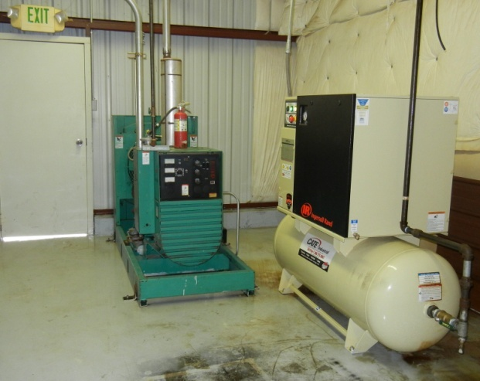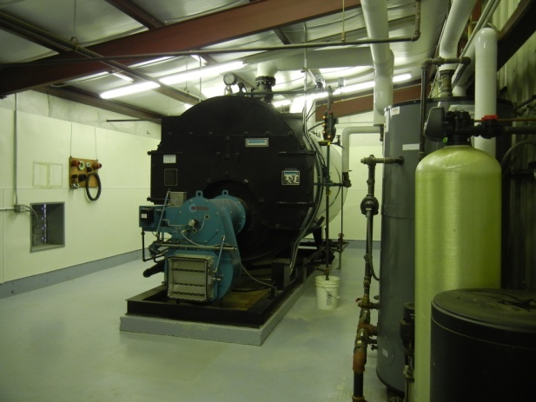
Generator/Air Compressor Room Boiler Area

Two separate rooms are used for ancillary equipment for the flake production plant operation. A boiler is located in one room. It is kept by itself since it generates a lot of heat. Outside ventilation is supplied to this room. An emergency generator and air compressor are installed in the second room. The emergency generator can run the flake production plant should the main electricity supply shut down. The air compressor supplies air to run some components of the double drum dryer such as the knife adjustments, and for cleaning.

Finished Flake Storage Warehouse

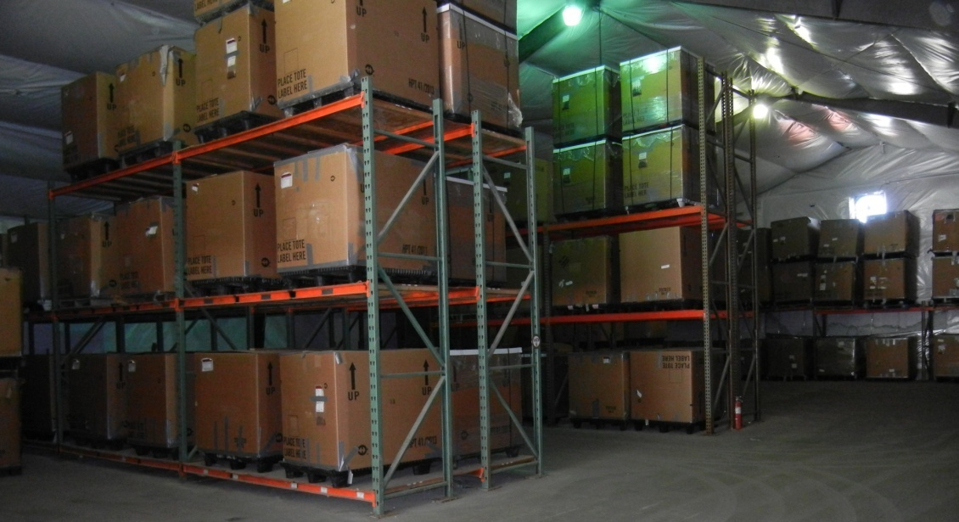

After the flakes are bulk stored into cardboard totes with sealed plastic liners, the totes are stored in the large 200 m² storage warehouse. The temperature of this warehouse is maintained at 10° C. Since all the totes are sealed here they are no longer attractive to insects. Rodents are controlled with spring traps. Additional ceiling fans help to reduce the temperature.

Flake Packing Materials Storage Area

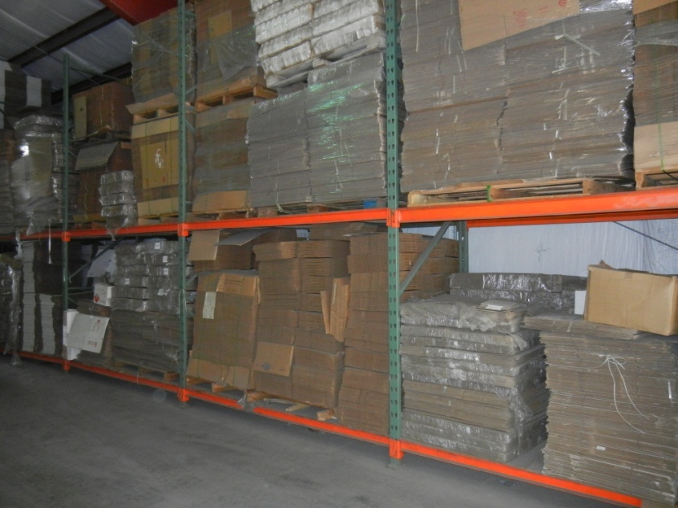

In a separate dry warehouse, approximately 130 m² is devoted to packing materials storage. This is the primary storage for boxes, cans, buckets, lids, and seals. This warehouse is held at ambient temperature.

Flake Packaging/Storage Area

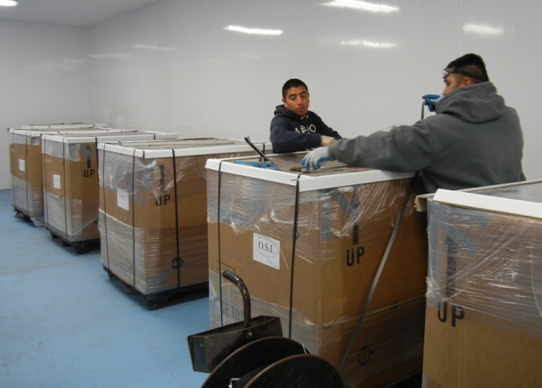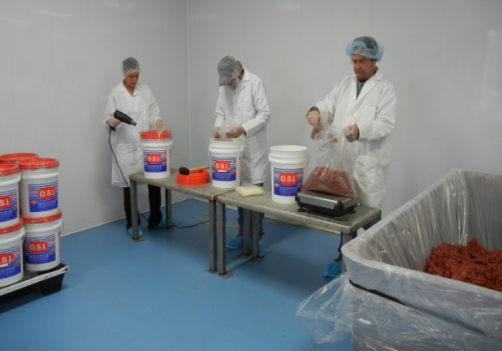
Bulk packaging (cardboard totes) Retail Packaging (buckets)

Two separate temperature controlled (21° C) packaging rooms of approximately 125 m² each are used for final packaging of flakes from bulk packaging cardboard totes into retail-sale containers if required by a customer. UV insect lights are installed to control flies and other flying insects. Floors and walls are washable. Stainless steel tables with various scales are used to measure flakes into retail-sale containers. Flake samples are pulled in this area for microbiological testing prior to shipping. Products packed for sale are maintained in this area until they are ready to be shipped.

Bulk flakes are moved into the area through a sally port. Only one overhead rollup door is opened at a time. Employees enter a separate man door. In a changing room, they don uniforms and/or lab coats, hair nets, and booties. A sink is provided for washing hands.

Laboratory
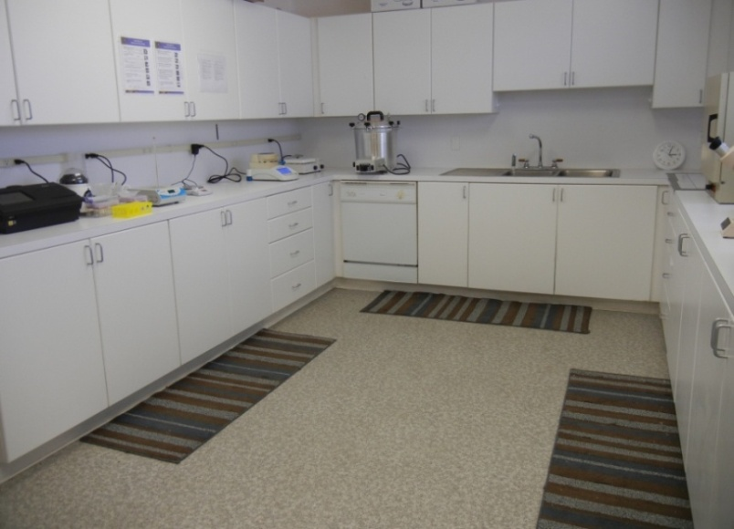

A temperature controlled laboratory of approximately 40 m² is used for quality control. The laboratory has filtered air and maintained at approximately 21° C. The laboratory consists of three areas:

- Main laboratory for sample preparation, general analysis and salmonella testing,
- Bacteria-controlled area with HEPA filters for bacterial sample preparation and enumeration,
- Record keeping and sample storage area.

Prior to shipping samples of products are pulled. Samples may be tested internally, at the State of Utah Department of Agriculture or at a private laboratory for general nutritional analyses. Samples are also tested for salmonella in-house or at a private laboratory. Entrobacteriaceae are either enumerated in-house or sent out to a private laboratory for enumeration. A typical report from a private laboratory approved by the US Department of Agriculture is attached as Addendum 3.

MAJOR EQUIPMENT

The major pieces of equipment for OSI’s flaking operation consist of the following:

- Grinding System for particle size reduction.

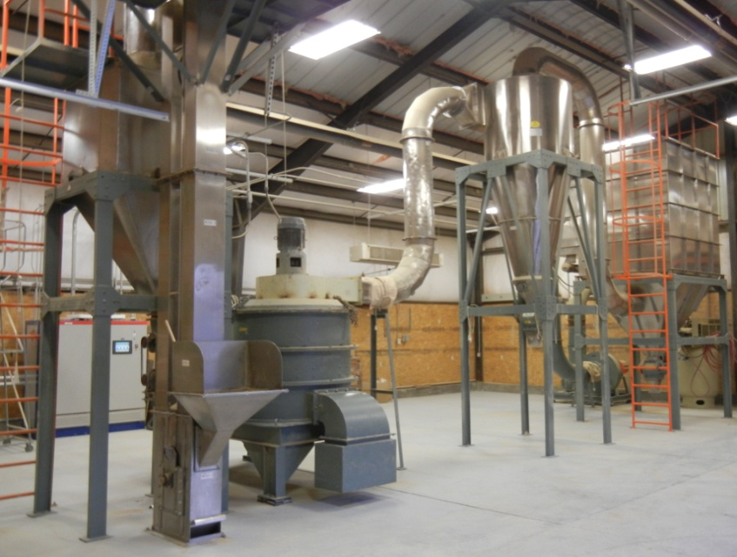

- 48” x 156” (122 cm x 396 cm) Buflowvak Double Drum Dryer. This machine was purchased new and installed at OSI in August 2014.

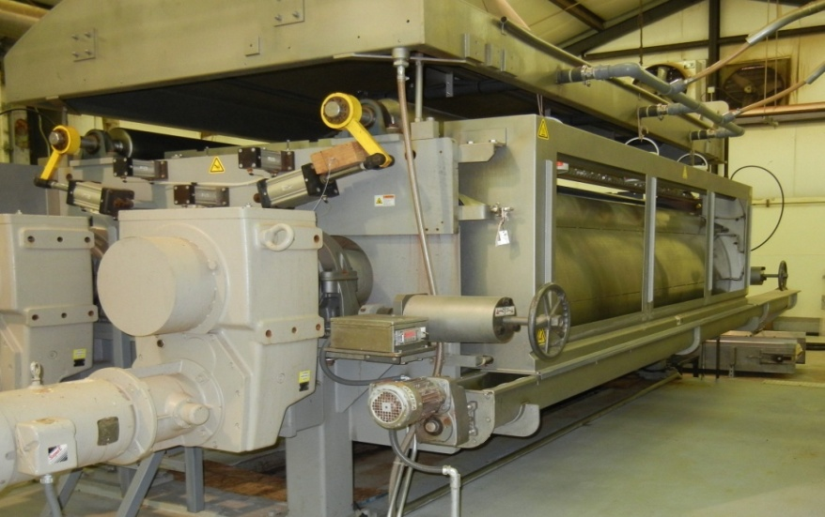

- 300-hp Boiler purchased new and installed at OSI. This supplies steam heat to the double drum dryer and heat for making hot water.

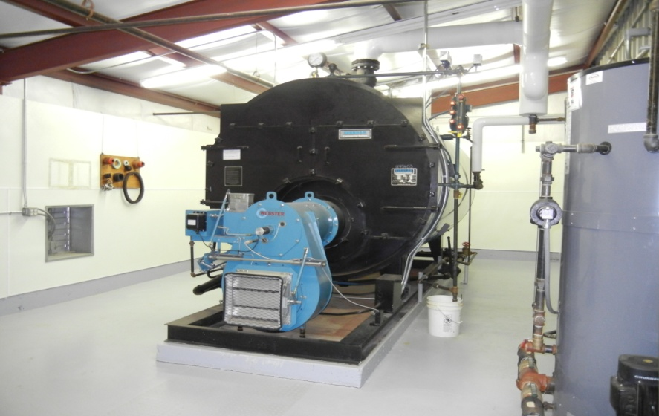

- One 1,100 L hot water kettle,

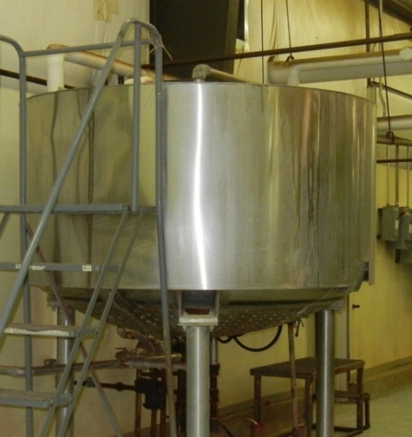

- Two 1,500 L mixing kettles,

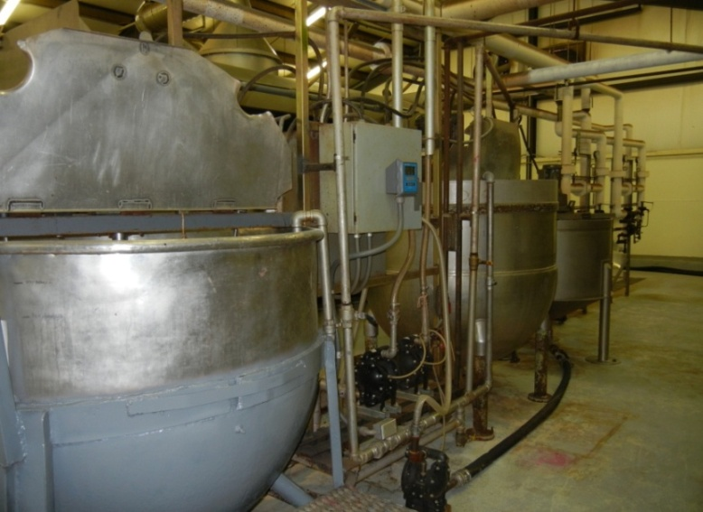

- Six mixing motors, three per mixing kettle to mix flake batch ingredients,

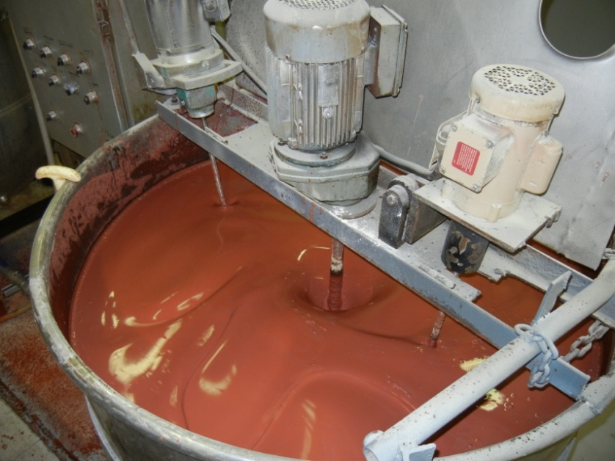

- 10 m long Drying Tunnel.

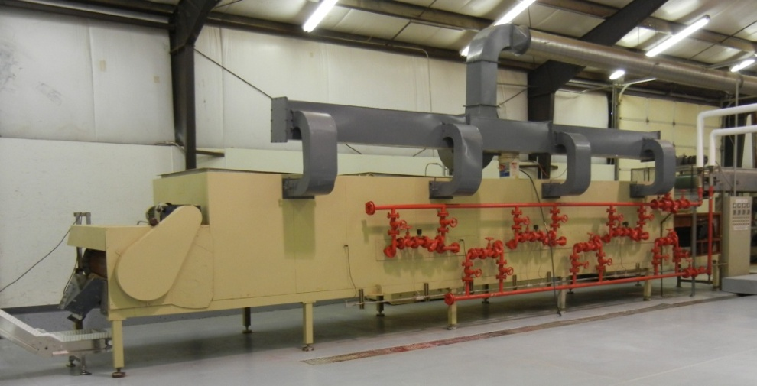

- Emergency electric generator,

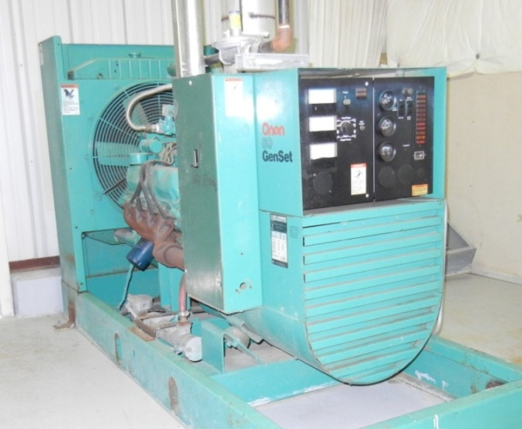

- Air compressor,
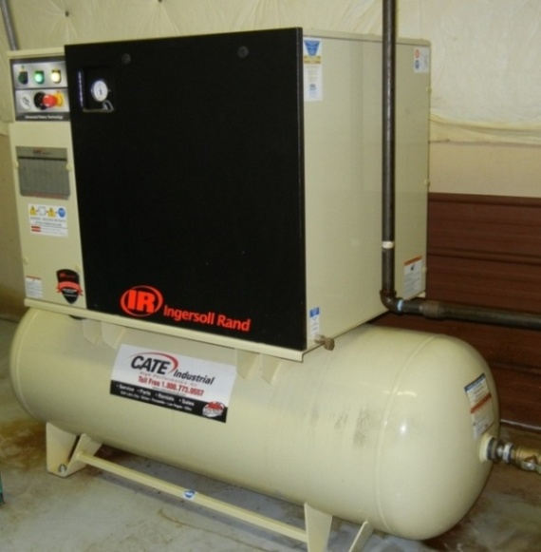

- Tote Dumper. It is used to transfer flakes from the aluminum metal mesh totes to the cardboard totes with plastic liners,

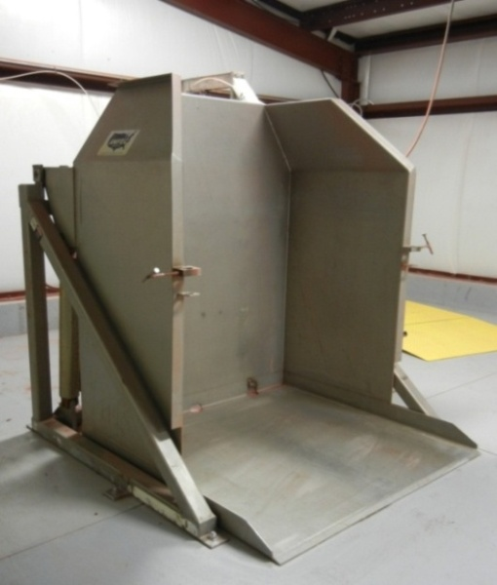

- Flake Tapper. Used to tamp down flakes in the cardboard totes to insure the totes are filled
uniformly.
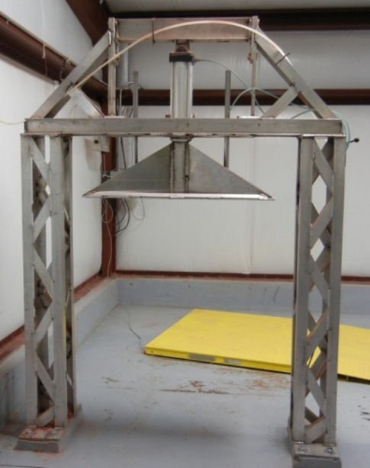
- Two 2-ton floor scale for measuring the finished weights of cardboard totes with plastic liners. One is used in the Flake Cooling Area and the other in the Flake Packaging/Storage Area.

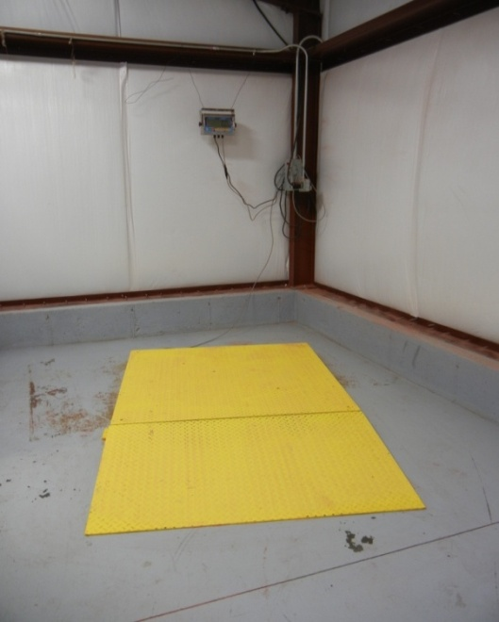

- Various small scales for mixing ingredients along with tools for weighing,
- Triple wash sink and drying racks for washing weighing tools and small machine parts.
- Stainless steel tables to work on for measuring out ingredients and retail-sale products.
- Three UV-light insect traps,

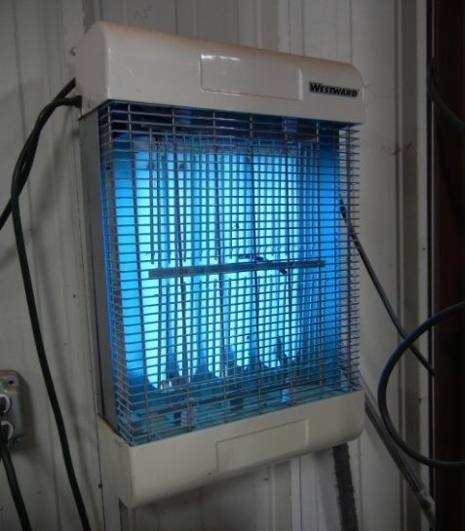

- Two 5-hp cooling systems for cooling the Flake Cooling Area.

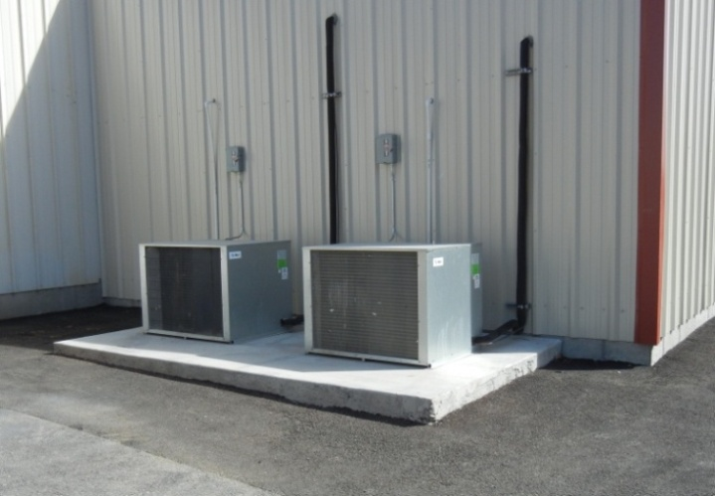
- 15-hp cooling systems for cooling ingredient storage areas for all ingredients, and the finished bulk flake storage area,

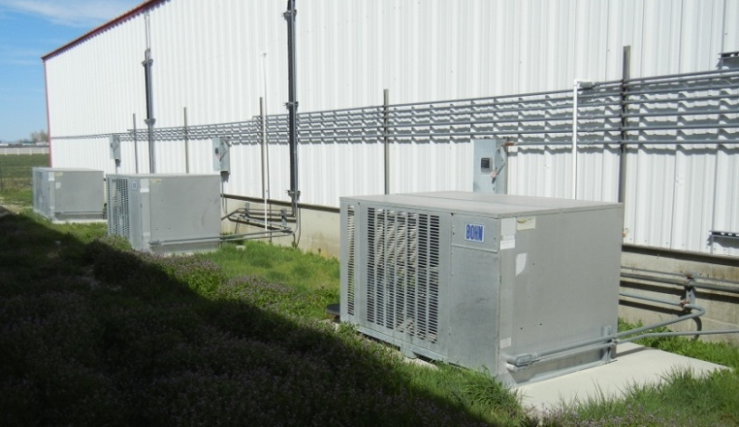

- 3-hp cooling/heating system for flake retail-sale packaging area,

- InstantLabsMediacal Diagnostics Corporation Hunter PRC Salmonella Testing Unit System.

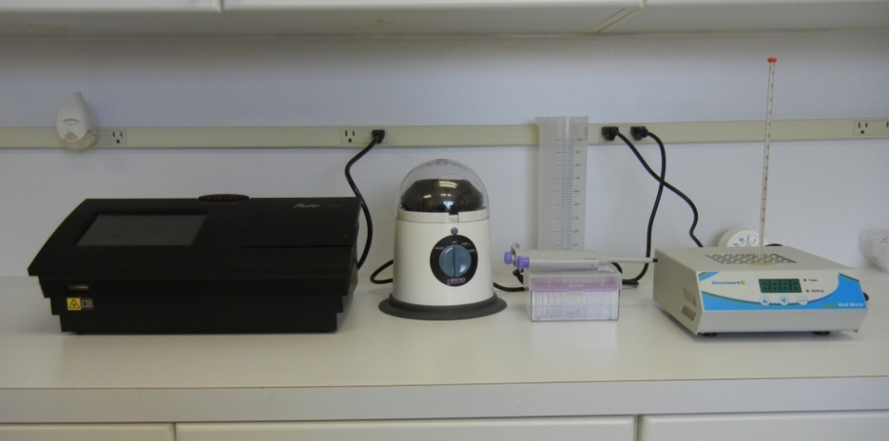

- 16 L Autoclave for sterilizing culture media,

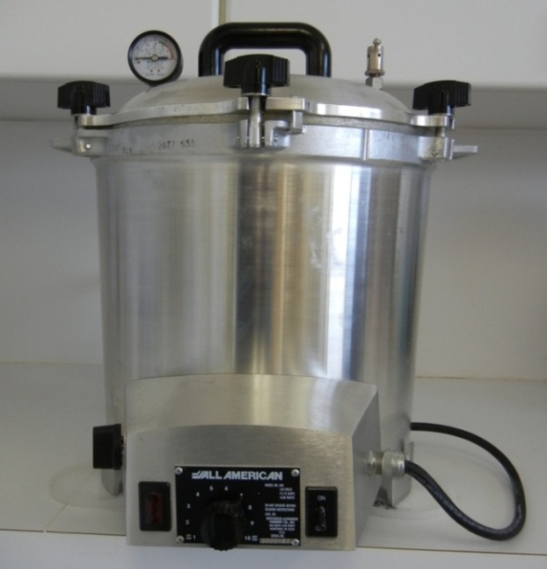

- Petri Plate incubator for culturing bacteria,

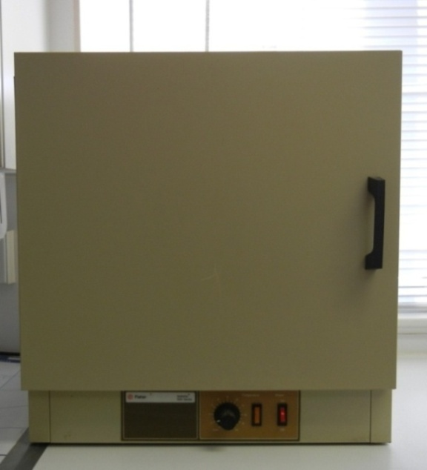

- Safety Hood for transferring bacterial cultures ,

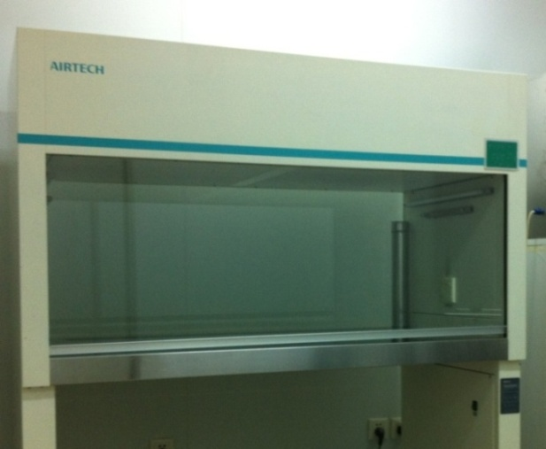

- Pass box for transferring samples into the bacterial-control area of the laboratory,

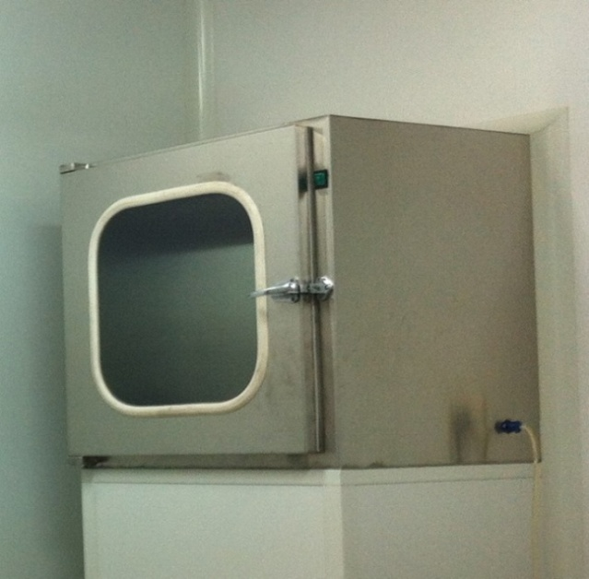

- Moisture meters for checking moisture in the flakes,

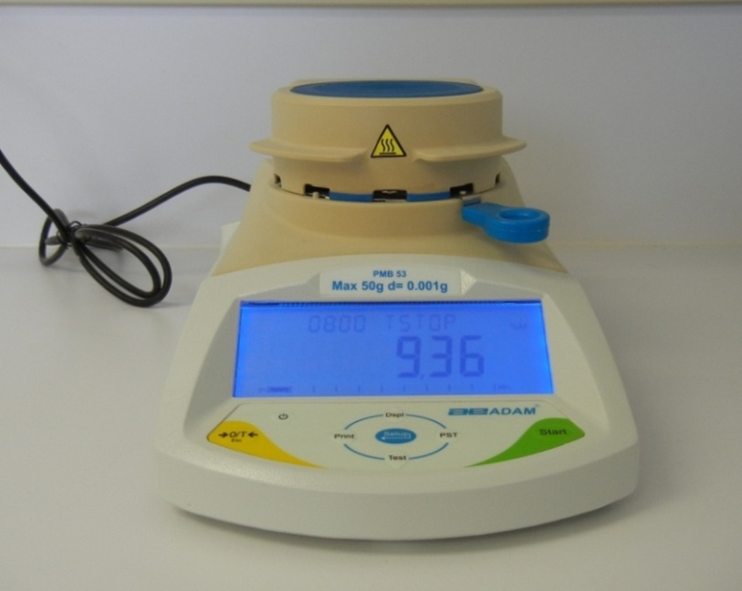

- High Density Liquid Chromatography Machine for Heavy Metal determination.
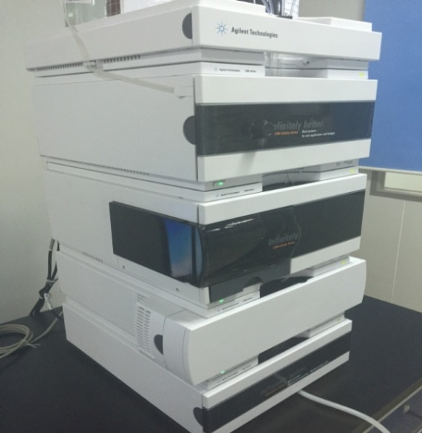

PRODUCTIN FLOW CHART WITH CURRENT GOOD MANUFACTURING PRACTICES (cGMP) SUMMARY

OSI invested in setting up a Current Good Manufacturing Practices (cGMP) program. This program was done in consultation with Brenda Stahl of NSF International, Inc., Ann Arbor, Michigan, USA (www.nsf.org) which is a non-profit consulting organization that helps companies set up Hazard Analysis Critical Control Programs (HACCP). HACCP programs focus more on plant safety issues more so than cGMP programs, which focus on the products themselves. However, there is some cross-over in the two types of programs. OSI developed the following cGMP program as a cross between the two types of programs. We also consulted with the US Food and Drug Administration GMP Checklist (21 CFR Part 110).

To better understand the process of making flakes a Process Flow Diagram is included as follows:.
Critical Control Points in the processing are indicated on the Process Flow Diagram. These are the control points for documentation.

